A dataset of hydrogen embrittlement in austenitic stainless steels measured in gaseous hydrogen, with weld metal separated from base metal
Muhammad Faizan
Independent researcher, Lahore, Pakistan
m.faizansworkspace@gmail.com

Abstract
This dataset assembles measurements of hydrogen embrittlement in austenitic stainless steels in which hydrogen was introduced as a gas, either by testing in high-pressure hydrogen or by thermal precharging in hydrogen gas. It contains 113 records extracted from the tables of nine sources published between 1983 and 2024, spanning 228 to 423 K and, for the 104 records whose source stated a pressure, 0.1 to 172 MPa. Each record describes one reported test condition and one mechanical property, with 30 fields covering alloy designation and heat, product form, weld process, filler metal, ferrite number, weld zone, hydrogen exposure mode, pressure, hydrogen content, test temperature, strain rate, the property measured in the reference environment and in hydrogen, and the ratio between them. Seventy-four records report a reduction of area, from which a relative reduction of area is obtained. The weld zone is recorded for every record, using a vocabulary of base metal, weld metal, heat affected zone, fusion line and whole welded joint, of which three are populated in this release. Electrochemically charged studies are excluded so that every record shares a single hydrogen source. Twenty-four records were independently re-extracted and matched. Completeness is reported for every field, and zone is cross-tabulated against alloy family so that the two can be separated. The dataset is provided as CSV and as a workbook with a summary, a data dictionary, a source list and an extraction log, together with the schema, validation, cleaning and plotting code.
Keywords: hydrogen embrittlement; austenitic stainless steel; weld metal; delta ferrite; gaseous hydrogen; relative reduction of area; literature-extracted dataset

Value of the Data
- Hydrogen was introduced as a gas in every record, and the gas pressure is recorded wherever the source stated one, so the records can be filtered on exposure mode and pressure without any conversion step.
- The weld zone is recorded for every record, so weld metal, whole welded joints and base metal can be filtered separately, and the alloy family of each record is recorded alongside it so that the two can be separated.
- The dataset can be used to train or test property-prediction models, to set screening criteria for alloy and filler selection in hydrogen service, and as a starting corpus for further extraction.
- Each record carries its source, table of origin and test conditions, so any value can be traced and checked, and corrections can be made against the original.
- The extraction schema, validation code and figure code are released with the data, so the compilation can be extended by others using the same fields and rules.

Specifications Table
Subject | Materials Science
Specific subject area | Hydrogen embrittlement of austenitic stainless steels and their welds, measured in gaseous hydrogen
Type of data | Table (CSV, XLSX), Figure (PNG), Code (Python), JSON records
How the data were acquired | Manual extraction from the tables of published handbooks, conference papers and journal articles into a JSON schema with type and range validation. Derived quantities computed in Python.
Data format | Raw (JSON extraction records), analysed (CSV, XLSX), filtered (gaseous hydrogen exposure only)
Description of data collection | Records were admitted when the material was an austenitic stainless steel or a closely related grade, hydrogen was introduced as a gas, a reference measurement existed from the same study and material, and the value appeared in a table rather than only in a figure.
Data source location | No new experiments were performed. Every value was extracted from a table in a published source; the primary sources are listed in the References and in the Sources sheet of the workbook. Extraction, curation and analysis were carried out by the author as an independent researcher in Lahore, Pakistan.
Data accessibility | Repository name: GitHub, archived on Zenodo. Direct URL: https://github.com/mfaizansworkspace-ai/Hydrogen-Embrittlement-in-Austenitic-SS. Zenodo DOI: 10.5281/zenodo.XXXXXXX (to be inserted from the archived v1.0 release before submission). Licences: data CC BY 4.0, code MIT.
Related research article | None. No article has been published using these data.

Objective
Austenitic stainless steels are used for high-pressure hydrogen service and are assembled by welding. Compilations of hydrogen embrittlement data for these steels exist, notably the Savannah River handbook [1] and the Sandia technical reference [2], and both are organised by alloy rather than by weld zone. Machine-learning studies of hydrogen embrittlement have drawn their training data from the literature [11], and a recent review identifies standardised hydrogen embrittlement databases as a requirement for further progress [12]. This dataset was assembled to provide, in a single machine-readable file, the austenitic stainless steel measurements that were made in hydrogen gas, with the weld zone recorded as a field so that weld and parent material can be separated.

1. Data Description
The dataset comprises 113 records. Each record describes one reported test condition and one mechanical property. The files provided are:
- he_austenite_v1.0.csv — the dataset, one record per row, 30 fields.
- HE-Austenite_v1.0.xlsx — the same records with a summary sheet, a data dictionary, a source list and an extraction log recording what was taken from each source and what was not.
- records_raw.json — the raw extraction records, including free-text notes giving the source table and the test conditions as the source stated them.
- scripts/ — the record schema (schema.json), validation and derived-value code (normalise.py), cleaning and export code (build_outputs.py, build_workbook.py) and figure code (make_figures.py).
- figures/ — the three figures reproduced below.
Table 1 lists the fields with the number of records for which each is populated. Table 2 gives the composition of the dataset by source. Table 3 cross-tabulates weld zone against alloy family. Table 4 gives the distribution by alloy family.
Table 1. Fields in the dataset, with the number of the 113 records for which each field carries a value. Fields populated for fewer than a quarter of records are the ones a user should check before relying on them.
Field | Content | Populated
record_id, source_id, source_short | Record identifier and source keys | 113, 113, 113
alloy, heat, material_family | Alloy designation as reported, heat or cast identifier, grouping used for analysis | 113, 16, 113
product_form, is_weld, zone | Plate, bar, sheet, tube or weld; whether the gauge contains weld metal; base metal, weld metal, HAZ, fusion line or whole joint | 113, 113, 113
weld_process, filler_metal, ferrite_number | Welding process, filler wire, ferrite number where reported | 60, 50, 2
hydrogen_exposure, h2_pressure_MPa, hydrogen_content_wppm, charging_time_h | Gaseous in-situ or gaseous precharge; gas pressure; hydrogen content; precharging duration | 113, 104, 52, 45
test_temperature_K, test_temperature_C, strain_rate_per_s, test_type | Test conditions | 113, 113, 64, 113
property_name, reference_environment, property_reference, property_h2, relative_ratio | Property measured, the environment it is compared against, the two values and their ratio | 113, 113, 103, 103, 113
embrittlement_flag, ni_equivalent, derived, verified, notes | Banding of the ratio; nickel equivalent where computable; which fields are derived; whether the record was independently re-extracted; provenance notes | 113, 14, 113, 113, 113
Three fields carry values for a minority of records and are noted here so that they are not mistaken for full coverage. Ferrite number is populated for 2 records, both composite 304L/308L welds from [2]; a user cannot model ferrite content against retained ductility from this release. Nickel equivalent is populated for 14 records, being those whose source printed a full composition. Heat identifiers are populated for 16 records. Md30 is not computed in this release, because too few sources report the nitrogen and carbon contents it requires.
Table 2. Records by source.
Source | Year | Records
Caskey, DP-1643 [1] | 1983 | 19
San Marchi and Somerday, SAND2012-7321 [2] | 2012 | 62
Balch et al. [3] | 2015 | 12
Younes et al. [4] | 2013 | 9
Nakamura et al. [5] | 2018 | 3
Fukunaga [6] | 2024 | 3
Michler et al. [7] | 2009 | 2
Iyer [8] | 1989 | 2
Matsuoka et al. [9] | 2017 | 1
Table 3. Weld zone against alloy family for the 74 records reporting a reduction of area. Each cell gives the number of records and, where any exist, their median relative reduction of area. The zone and family distributions are not independent, so the two must be read together rather than separately.
Alloy family | Base metal | Whole welded joint | Weld metal | All
Type 304 family | 14 / 0.72 | 8 / 0.59 | 12 / 0.48 | 34 / 0.53
Types 316 and 317 | 8 / 0.99 | 4 / 0.96 | 2 / 0.73 | 14 / 0.96
Types 321 and 347 | 3 / 0.91 | — | — | 3 / 0.91
21-6-9 | 2 / 0.98 | 12 / 0.87 | — | 14 / 0.92
22-13-5 | 4 / 1.01 | — | — | 4 / 1.01
Type 310 | 2 / 0.97 | — | — | 2 / 0.97
Duplex 2507 | 2 / 0.43 | — | — | 2 / 0.43
A286 | 1 / 0.51 | — | — | 1 / 0.51
All families | 36 / 0.85 | 24 / 0.83 | 14 / 0.49 | 74 / 0.80
The three zone groups draw on different sets of sources and different alloy families, so the column totals in Table 3 are not a like-for-like comparison. The 36 base-metal records come from seven sources and eight families; the 24 whole-joint records come from a single source [2] and three families; the 14 weld-metal records come from three sources [3,4,5] and two families, and 12 of the 14 are type 304 family. The within-family rows are where zone can be read against a fixed alloy: in the type 304 family, 14 base-metal records give 0.72 and 12 weld-metal records give 0.48, and in types 316 and 317, 8 base-metal records give 0.99 against 2 weld-metal records at 0.73.
Table 4. Relative reduction of area by alloy family, reduction-of-area records only. All 74 records are accounted for.
Alloy family | Records | Median | Minimum | Maximum
Type 304 family | 34 | 0.53 | 0.35 | 0.91
Types 321 and 347 | 3 | 0.91 | 0.46 | 1.01
Types 316 and 317 | 14 | 0.96 | 0.54 | 1.07
21-6-9 | 14 | 0.92 | 0.80 | 1.25
22-13-5 | 4 | 1.01 | 0.99 | 1.48
Type 310 | 2 | 0.97 | 0.96 | 0.99
Duplex 2507 | 2 | 0.43 | 0.31 | 0.54
A286 | 1 | 0.51 | 0.51 | 0.51
Fifty-nine records describe specimens precharged in hydrogen gas and 54 specimens tested in hydrogen gas. The reference environment is air for 48 records, high-pressure helium for 28, the uncharged condition for 32, and nitrogen or argon for 5. The properties recorded are reduction of area (74 records), elongation (32), plastic strain to failure (4), tensile strength (2) and notched tensile strength (1). Hydrogen pressure is recorded for 104 records and spans 0.1 to 172 MPa; the nine records without a pressure are the thermally precharged specimens of [4], which the source characterises by hydrogen content in weight ppm rather than by charging pressure.
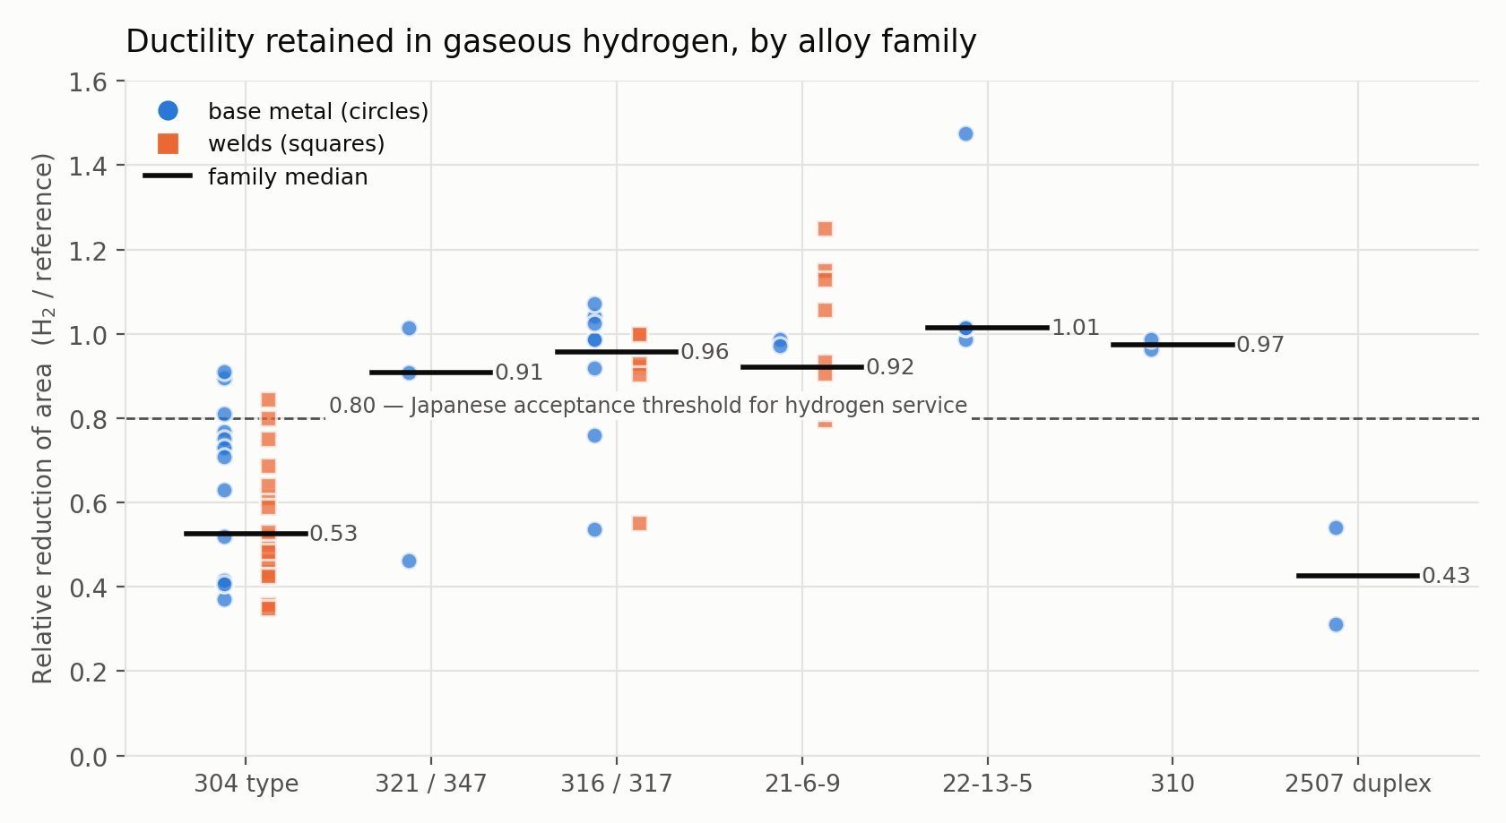
Fig. 1. All 74 reduction-of-area records, grouped by alloy family. Circles denote base metal, squares denote welds, horizontal bars denote family medians. The dashed line marks 0.80, the value used in Japanese regulatory practice to accept an austenitic stainless steel for hydrogen service. Family membership and weld zone are not independent, so the family medians should be read with Table 3.
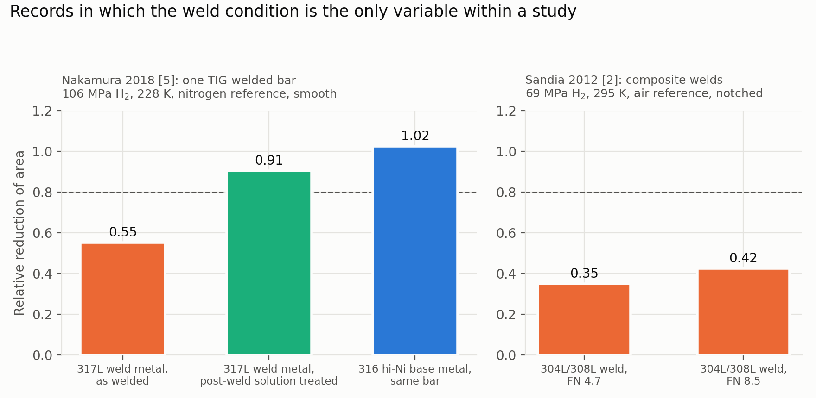
Fig. 2. Two groups of records in which the weld condition is the only variable within a study. The two panels differ in alloy system, pressure, temperature, reference environment and specimen geometry, as each subtitle states, and are therefore not comparable with one another. Left: one TIG-welded bar tested in three conditions [5]. Right: notched composite 304L/308L welds at two ferrite numbers [2]; the higher ferrite number is the less embrittled of the pair.
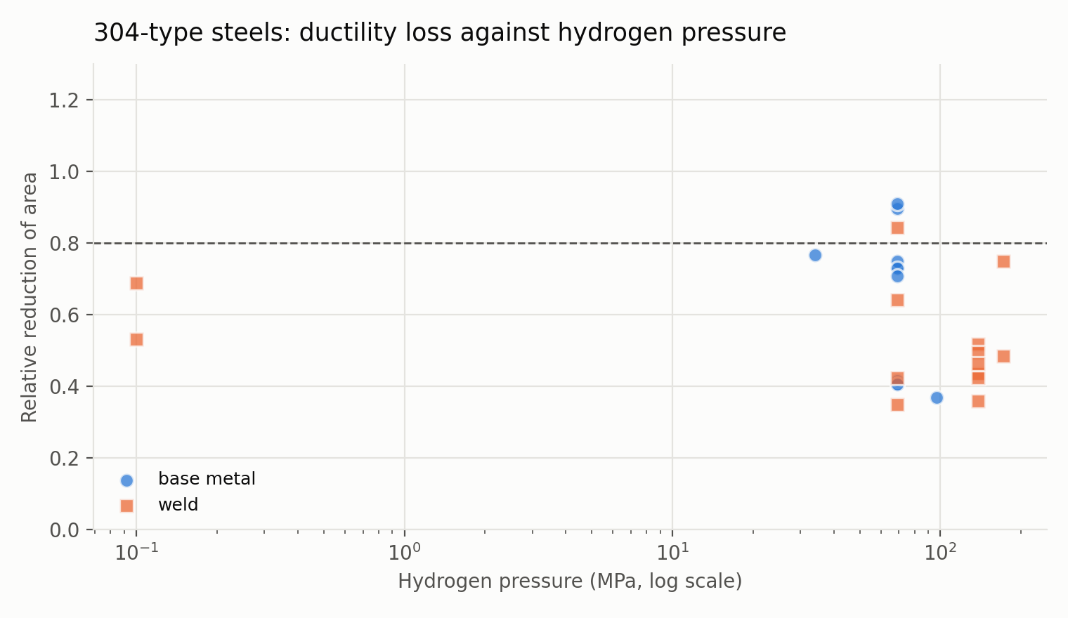
Fig. 3. The 25 type 304 family reduction-of-area records that carry a hydrogen pressure, plotted against pressure on a logarithmic axis and separated into base metal and welds. The nine records of [4] are omitted because their source states hydrogen content rather than pressure.
The records plotted in the left panel of Fig. 2 come from one TIG-welded bar tested in three conditions at 228 K in 106 MPa hydrogen against a nitrogen reference [5]: the parent 316 (hi-Ni) at 1.02, the 317L weld metal as welded at 0.55, and the same weld metal after a post-weld solution treatment at 0.91. The right panel holds the only two records in the dataset that carry a measured ferrite number: notched composite 304L/308L welds at ferrite numbers of 4.7 and 8.5 tested in 69 MPa hydrogen against an air reference, at 0.350 and 0.425 respectively [2].

2. Experimental Design, Materials and Methods
2.1 Selection of sources
Candidate sources were identified between 16 and 22 September 2026 by keyword searches of the academic literature, covering combinations of hydrogen embrittlement, hydrogen environment embrittlement, austenitic stainless steel, weld metal, delta ferrite, gaseous hydrogen, high-pressure hydrogen and slow strain rate tensile testing, and by following the citation lists of the two existing compilations [1,2] and of every source admitted. Forty-three candidate sources reached full-text screening. Of these, nine were used, five were read in full and set aside with their reason recorded, and the remainder were set aside at the title and abstract stage, chiefly for electrochemical charging. A source was used when it reported, in a table, a mechanical property measured after or during exposure to hydrogen gas together with a reference measurement on the same material. Identification, screening and extraction were performed by one person; there was no second independent screener, which is recorded in the Limitations.
2.2 Inclusion and exclusion
A record was admitted when four conditions held: the material was an austenitic stainless steel, or a closely related grade flagged by material family; hydrogen was introduced as a gas, either in situ or by thermal precharging; a reference measurement existed from the same study and material, in air, helium, nitrogen, argon or the uncharged condition; and the value appeared in a table.
Studies using electrochemical or cathodic charging were excluded, because the hydrogen fugacity produced cannot be converted to an equivalent gas pressure without assumptions about charging efficiency. Four studies reporting relevant results only in figures were excluded: Hirata [10], Yamabe et al. (2017), Zhang et al. (2013), and the remainder of Matsuoka et al. [9] beyond the one numeric value used. Burst tests whose controls were literature values rather than paired specimens were also excluded. The excluded sources and the reason for each are recorded in the extraction log sheet of the workbook, which also lists sources identified after extraction closed as candidates for a later release.
2.3 Extraction
Values were transcribed manually from source tables into a JSON schema (scripts/schema.json) that constrains field types and value ranges. Free-text notes record the source table, the test conditions as stated, and any caveat the source attached to the value. Units were normalised to MPa, K, wt ppm, hours and reciprocal seconds. Alloy designations were standardised and heat identifiers moved to a separate field.
2.4 Derived quantities
Two quantities are computed rather than transcribed, and both are flagged in the derived field. The relative ratio is the property measured in or after hydrogen divided by the property in the reference environment; where the property is reduction of area this is the relative reduction of area. For 103 of the 113 records the source printed both absolute values and the ratio was computed from them. For the nine records of [4] the source printed a percentage loss rather than two absolute values, and the ratio was computed as one minus the loss divided by one hundred; those records therefore carry a relative ratio but no property_reference or property_h2, and the arithmetic is recorded in their notes. For the single record of [9] the source printed the ratio itself, which was transcribed. Nickel equivalent is computed on the Hirayama form where the source reports a full composition, which is the case for 14 records. Where a source printed its own ratio alongside the absolute values, the computed value was compared against it; for the six weld positions of Balch et al. [3] the computed values of 0.52, 0.44, 0.36, 0.46, 0.43 and 0.49 reproduce the published values of 51, 43, 36, 47, 42 and 49 percent within rounding.
2.5 Validation
Five checks were applied. Tables from two sources [1,3] were re-extracted independently from the source documents and compared against the stored values, covering 24 records, all of which matched; those records carry verified = yes. Each of the 103 ratios computed from a pair was recomputed from its stored pair and agreed to within 0.002. Every record was checked against the inclusion rule to confirm gaseous exposure. Every value recorded as a percentage was checked to lie between 0 and 100. Every record was validated against the JSON schema, and record identifiers were checked for uniqueness.
During validation one disagreement between sources was resolved. The Savannah River handbook reports annealed type 304L at 81 percent reduction of area in 69 MPa helium against 33 percent in 69 MPa hydrogen, with the high energy rate forged condition at 77 against 69 [1]. A secondary reading attributed the first pair to the forged condition. The Sandia type 304 chapter lists the forged condition separately with air-only values [2], which supports the assignment in [1]. Both records carry a note recording this.

Limitations
The dataset contains 113 records, of which 74 report a reduction of area. Types 321 and 347 are represented by three records, duplex 2507 by two, type 310 by two and A286 by one, so summary values for those families rest on few measurements.
Weld zone and alloy family are not independent, as Table 3 shows. Weld metal is represented by 14 records from three sources, 12 of which are type 304 family, while base metal is represented by 36 records spanning eight families and including the more stable grades. Any comparison of the zone column totals therefore carries an alloy effect as well as a zone effect, and the within-family rows of Table 3 are the appropriate basis for reading one against the other. The heat affected zone and fusion line are defined in the zone vocabulary but carry no records in this release.
Measurements reported only in figures are not included. Four studies relevant to the scope fall in this category. The most significant is [10], which reports relative reduction of area against delta ferrite ratio for ten weld metals tested in 45 MPa hydrogen gas, and which concludes that weld-metal embrittlement is governed by austenite stability, expressed as Md30 or nickel equivalent, rather than by delta ferrite. That conclusion runs opposite to the reading in [5], and users of the ferrite_number field should be aware that the question is contested in the primary literature. Ferrite number is in any case populated for only two records, so this release cannot be used to test either position.
Reference environments are mixed. A reference measured in high-pressure helium at the test pressure separates the chemical effect of hydrogen from the mechanical effect of pressure, while a reference measured in air does not. The field is recorded for every record so that users can filter, and the summary values reported in Tables 3 and 4 combine them. Twelve of the 14 weld-metal records use an uncharged reference, which reflects their origin in thermal-precharge studies rather than in-situ gas testing.
Hydrogen pressure is recorded for 104 of 113 records. The nine records of [4] are characterised by hydrogen content instead, so they cannot be placed on a pressure axis and are omitted from Fig. 3.
Twenty-four of 113 records have been independently re-extracted. The remainder have passed schema, ratio, scope, uniqueness and range checks only. Identification, screening and extraction were carried out by one person without a second independent screener, so screening error cannot be quantified. Several sources report a single test per condition, so no uncertainty is recorded because none was published. Records taken from the two compilations [1,2] are one step removed from the original experiments; the primary citations given by those compilations are preserved in the notes field.
Sources identified after extraction closed are recorded in the extraction log as candidates for a later release rather than silently omitted. They include a study of GTAW 316L joints tested in high-pressure hydrogen gas at two weld heat inputs with the ferrite content varied [13], a study of type 304 with delta ferrite tested in 5 MPa hydrogen against argon [14], and the Japanese original [15] of the translated source [10], which may print as a table what the translation shows only as a figure.

Ethics Statement
The work did not involve human subjects, animal experiments or data collected from social media platforms. All values were extracted from published tables. No copyrighted material is redistributed: the repository contains extracted numerical values together with the citation and table of origin for each, and no source document.

Data Availability
The dataset, the extraction schema, the validation, cleaning and plotting code, the spreadsheet workbook and the figures are openly available in the GitHub repository at https://github.com/mfaizansworkspace-ai/Hydrogen-Embrittlement-in-Austenitic-SS, archived at release v1.0 on Zenodo under DOI 10.5281/zenodo.XXXXXXX. Data files are licensed CC BY 4.0 and code MIT. No restrictions apply.

Funding
This work received no specific grant from any funding agency in the public, commercial or not-for-profit sectors.

CRediT Author Statement
Muhammad Faizan: Conceptualization, Data curation, Formal analysis, Investigation, Methodology, Software, Validation, Visualization, Writing – original draft.

Declaration of Generative AI and AI-Assisted Technologies
During the preparation of this work the author used Claude, a large language model developed by Anthropic, to assist with searching the literature, with writing the Python extraction, validation and plotting code, and with drafting and editing the text of this article. The model was not used to generate, estimate, infer or impute any data value. Every value in the dataset was read by the author from a published table and transcribed; the re-extraction pass described in Section 2.5 was performed against the source documents. The author reviewed and edited the output, verified the numerical content of this article against the released dataset, and takes full responsibility for the content of the publication. The model is not listed as an author.

Declaration of Competing Interest
The author declares that he has no known competing financial interests or personal relationships that could have appeared to influence the work reported in this paper.

Acknowledgements
The author thanks the authors and institutions whose published tables make this compilation possible, in particular the Savannah River and Sandia National Laboratories reference works, which remain open to the public.

References
[1] G.R. Caskey Jr., Hydrogen Compatibility Handbook for Stainless Steels, Report DP-1643, Savannah River Laboratory, Aiken, SC, 1983. https://www.osti.gov/biblio/5906050
[2] C. San Marchi, B.P. Somerday (Eds.), Technical Reference on Hydrogen Compatibility of Materials, Report SAND2012-7321, Sandia National Laboratories, Livermore, CA, 2012. https://h2tools.org/technical-reference
[3] D.K. Balch, C. San Marchi, B.P. Somerday, J.A. Ronevich, Effect of hydrogen on tensile strength and ductility of multipass 304L/308L austenitic stainless steel welds, in: Proc. ASME 2015 Pressure Vessels and Piping Conference, Paper PVP2015-45591, Boston, MA, 2015.
[4] C.M. Younes, A.M. Steele, J.A. Nicholson, C.J. Barnett, Influence of hydrogen content on the tensile properties and fracture of austenitic stainless steel welds, Int. J. Hydrogen Energy 38 (2013) 4864–4876.
[5] J. Nakamura, S. Okazaki, H. Matsunaga, S. Matsuoka, SSRT and fatigue life properties of 317L austenitic stainless steel weld metal in high-pressure hydrogen gas, Trans. JSME 84 (857) (2018) 17-00437 (in Japanese). https://doi.org/10.1299/transjsme.17-00437
[6] A. Fukunaga, Hydrogen embrittlement behaviors during SSRT tests in gaseous hydrogen for cold-worked type 316 austenitic stainless steel and iron-based superalloy A286 used in hydrogen refueling station, Eng. Fail. Anal. 160 (2024) 108158. https://doi.org/10.1016/j.engfailanal.2024.108158
[7] T. Michler, Y. Lee, R.P. Gangloff, J. Naumann, Influence of macro segregation on hydrogen environment embrittlement of SUS 316L stainless steel, Int. J. Hydrogen Energy 34 (7) (2009) 3201–3209. https://doi.org/10.1016/j.ijhydene.2009.02.015
[8] K.J.L. Iyer, The influence of hydrogen on the mechanical properties and structure of a stable 304 stainless steel, Can. Metall. Q. 28 (2) (1989) 153. https://doi.org/10.1179/cmq.1989.28.2.153
[9] S. Matsuoka, J. Yamabe, H. Matsunaga, Hydrogen-induced ductility loss of austenitic stainless steels for slow strain rate tensile testing in high-pressure hydrogen gas, Solid State Phenom. 258 (2017) 259–264. https://doi.org/10.4028/www.scientific.net/SSP.258.259
[10] K. Hirata, Effects of chemical compositions and microstructure on hydrogen embrittlement of austenitic stainless steel weld metal in a high-pressure gaseous hydrogen environment, Weld. Int. 29 (12) (2015) 922–927. https://doi.org/10.1080/09507116.2014.921084
[11] S. Chandrakar, et al., Elucidating the influence of alloying elements on hydrogen embrittlement in steels through machine learning-aided property prediction, Modelling Simul. Mater. Sci. Eng. (2025). https://doi.org/10.1088/1361-651X/adf242
[12] A.G. Talkhan, et al., Machine learning-driven advances in hydrogen embrittlement of steels: a comprehensive review, Hydrogen (2026).
[13] J. Nakamura, et al., Hydrogen embrittlement properties of austenitic stainless steel type 316L welded joint, J. Soc. Mater. Sci. Japan (2024).
[14] F. Bao, et al., Effect of delta-ferrite on susceptibility to hydrogen embrittlement of 304 austenitic stainless steel in high-pressure hydrogen atmosphere, Anti-Corros. Methods Mater. (2021).
[15] H. Hirata, et al., Effects of chemical compositions and microstructure on hydrogen embrittlement of austenitic stainless steel weld metal in high pressure gaseous hydrogen environment, Q. J. Jpn. Weld. Soc. (2013).

